Holiday Planner Web Application

Course: UI/UX Design Fundamentals Institution: Christ University

Group Members:

* Sricharan A - 2462532
* Swara Madichedi - 2462533
* Anirudh V O - 2462536

# Project Overview

The Holiday Planner application is a browser-based trip management tool designed to help users plan vacations, choose destinations, build itineraries, and track budgets

efficiently. Built using HTML, Bootstrap 5, JavaScript, and jQuery, the app features an

interactive interface with search, filter, selection, and budgeting capabilities. By utilizing the localStorage API, users’ itinerary data persists across sessions, offering a seamless planning experience. Users can search for destinations, view and select accommodations and

transportation, plan activities, and maintain a running cost tally. This demonstrates how modern web front-end technologies can be integrated to deliver responsive and user- friendly travel planning solutions.

# Objectives

* Design a simple and intuitive user interface for trip planning.
* Allow searching, filtering, and selecting destinations by type (beach, mountain, city, adventure).
* Enable users to add selected accommodations, transportation, and activities to their itinerary.
* Track and display the estimated costs of planned trips in real-time.
* Store itinerary details and user preferences using the browser’s localStorage, ensuring persistent planning data.

1. Expected Outcomes

* A fully functional web-based Holiday Planner enabling end-to-end travel organization.
* Responsive, appealing UI using Bootstrap, suitable for mobile, tablet, and desktop devices.
* Accurate categorization, selection, and cost calculation for accommodations, transport, and activities.
* Data persistence across browser sessions.
* Foundational structure for enhancements like cloud sync, reminders, calendar integration, and advanced analytics.

1. Pages & Design
   1. Home Page: Main Application Screen

* Header: Displays "Holiday Planner" and app purpose.
* Search & Filter Panel: Input field for searching destinations, dropdown to filter by type, “Reset” button.
* Destinations List: Cards show destination name, type, description, average cost, and “Select” button.
* Planner Controls: After selection, dropdowns allow choosing accommodation, transport, and planning activities with date & time selection, "Add to Itinerary" button.
* Itinerary Section: List of all planned activities (with cost), “Done” and “Delete” buttons, total cost calculator.
* Budget Tracker: Itemized cost list and total, with "Clear Itinerary" option.
* Footer/Demo Note: Explains use of sample data and persistence.

1. Design Choices

* Font: Clean, readable typography via Bootstrap defaults.
* Color Palette: Light, muted backgrounds with colored accents.
* Layout: Utilizes Bootstrap grid for balanced columnar layout.
* Accessibility: Semantic HTML tags, predictable navigation, and descriptive labels for all controls.
* Responsiveness: Adapts to mobile, tablet, and desktop using media queries and Bootstrap utilities.

1. Technical Implementation

* Built with HTML5, Bootstrap 5, JavaScript, and jQuery.
* App state organized as JavaScript objects for destinations, itinerary, and cost selections.
* LocalStorage persists trip data, selections, and itinerary items.
* Dynamic rendering functions update destinations, itinerary, and cost in real time based on user actions.
* Core features: search/filter, select destination, add activities, recalculating total cost, clear/reset options, marking activities as done.

1. Sample Code Snippets

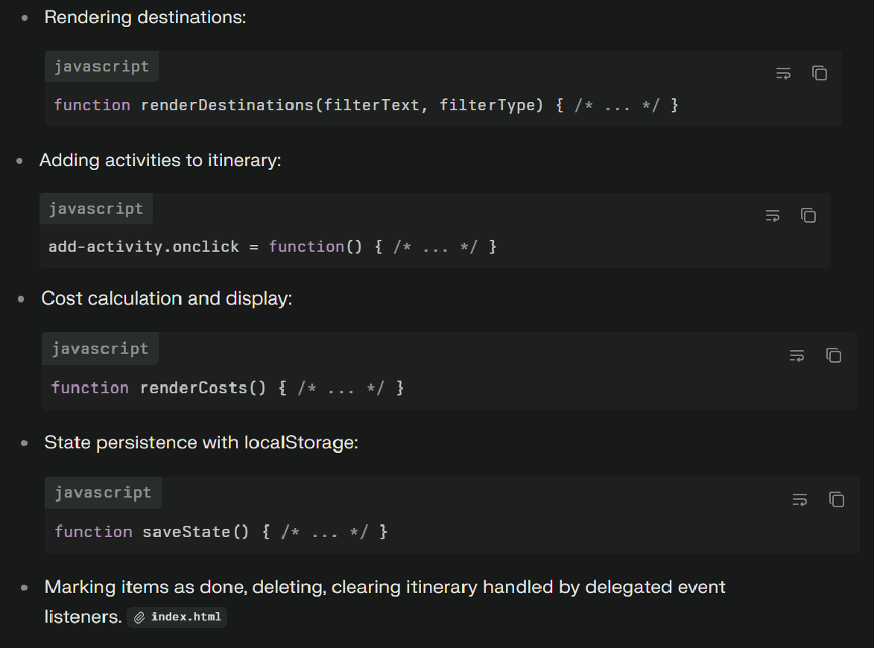

# Screenshots

1. Home Page

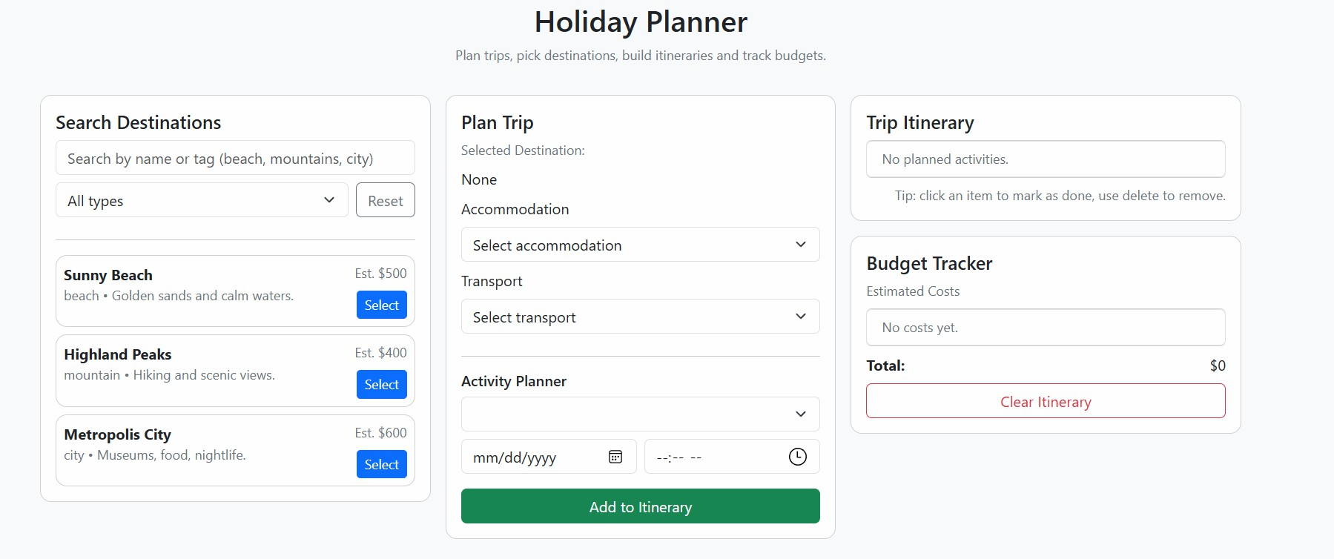

1. Plan Trip-Selected Destination

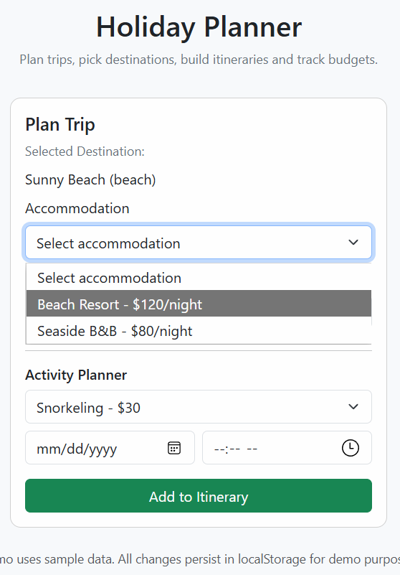

1. Trip Itinerary and Budget Tracker
2. 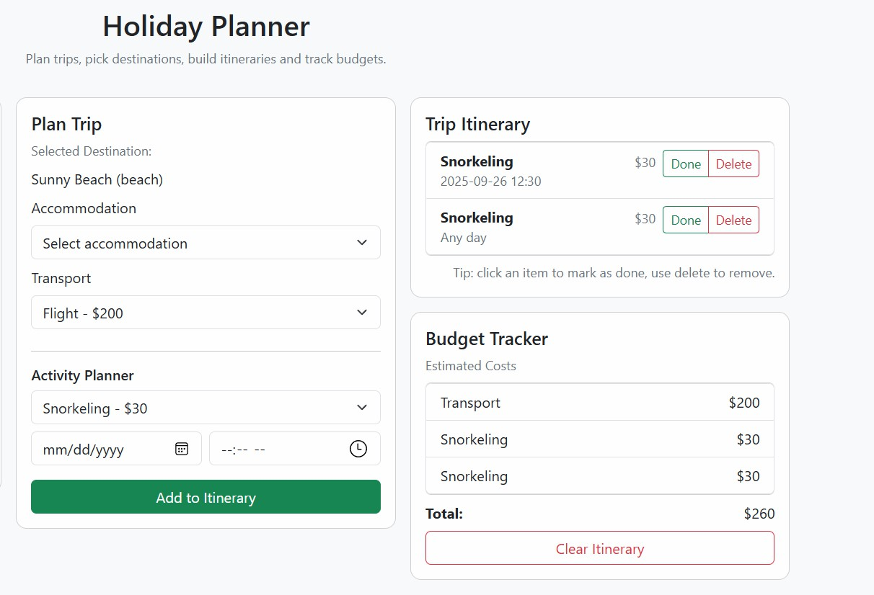Clear Itinerary

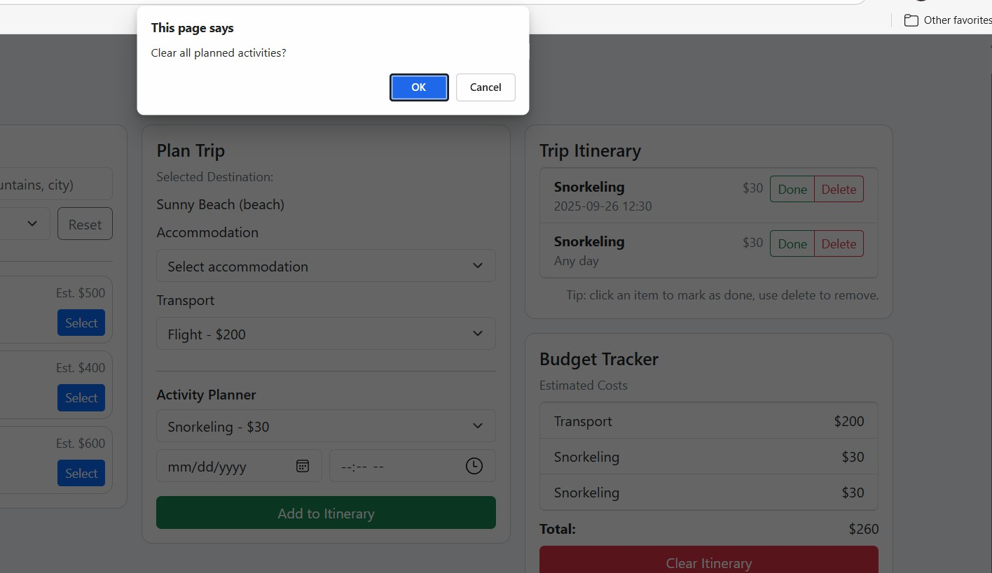

1. **Team Members and roleplay:**

* Swara Madichedi (2462533): UI design, styling, documentation.
* Sricharan A (2462532): Search & filter, localStorage, testing.
* Anirudh VO: Itinerary & budget tracker, JavaScript integration, debugging**.**

# GitHub & Submission

Repository: https://github.com/sricharan-abtech/Front-End-UI-UX-Webpage-Design-CIA3

# Final Checklist

* Pages implemented: index, about, projects, contact
* Semantic HTML used
* CSS responsive design
* Project report attached in repository
* GitHub repository public and linked in spreadsheet

Sricharan A - 2462532 - [sricharan.a@btech.christuniversity.in](mailto:sricharan.a@btech.christuniversity.in)

Swara Madichedi - 2462533 - [swara.madichedi@btech.christuniversity.in](mailto:swara.madichedi@btech.christuniversity.in) Anirudh VO - 2462536 - [vo.anirudh@btech.christuniversity.in](mailto:vo.anirudh@btech.christuniversity.in)